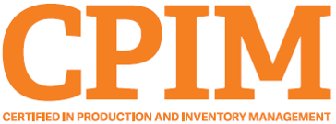
Let’s do this together.
Cincinnati APICS

You know that the CPIM credential will benefit your career immediately, so don't delay your CPIM exam preparations any longer.

What's Stopping You?

We can help you overcome your biggest obstacles:
- Time. Our instructor will lead you through the most efficient and effective way to earn your certification.
- Cost. Save money and time by preparing the right way, the first time. Plus, our course qualifies for most employer tuition reimbursement programs.
- Boss. We can help you to approach your boss and prove the value of certification for your organization.

Enroll in Cincinnati APICS's Exam Prep Class today and take a step toward your future!

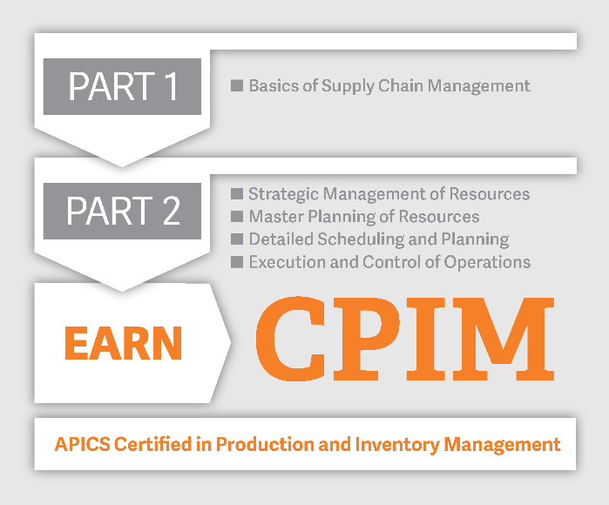
Upcoming Classes
Select a class that fits your schedule:

CPIM Part 1 – Start your CPIM journey with universally recognized entry-level supply chain training. Learn the Basics of Supply Chain Management and prepare for the CPIM Part 1 exam.

Click here for course schedule and offerings

CPIM Part 2 – Complete your CPIM preparation journey. Prepare for the CPIM Part 2 exam with comprehensive training for internal operations covering master planning, detailed scheduling, execution and strategic management of resources.

Click here for course schedule and offerings

Register now. Classes fill quickly and space is limited.

